Project Design Phase-II

Technology Architecture

|  |  |
| --- | --- |
| Date | 11 October 2022 |
| Team ID | PNT2022TMID07522 |
| Project Name | SMART FARMER - IOT ENABLED SMART FARMING APPLICATION |
| Maximum Mark | 4 Marks |

**Technical Architecture**:

The Deliverable shall include the architectural diagram as below and the information

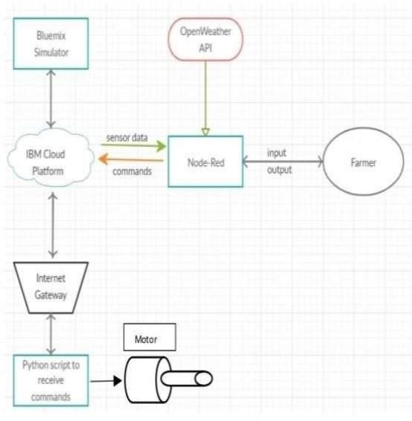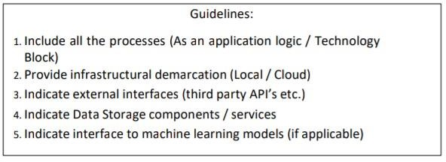

* The different soil parameters temperature, soil moistures and then humidity are sensed using
* different sensors and obtained value is stored in the IBM cloud. Arduino UNO is used as a processing Unit that process the data obtained from the sensors and whether data from the weather API
* NODE-RED is used as a programming tool to write the hardware, software, and APIs. The MQTT protocol is followed for the communication. All the collected data are provided to the user through a mobile application that was developed using the MIT app inventor.
* The user could decide through an app, weather to water the crop or not depending upon the sensor values. By using the app, they can remotely operate the motor switch.

